A repair station technician writes, "During inspection of the wing flap actuator attachments, *(I)* found both the L/H and R/H wing inboard flap-fairing hinge fittings cracked *(P/N's 390-110440-0001 and 390-110440-0002)*."

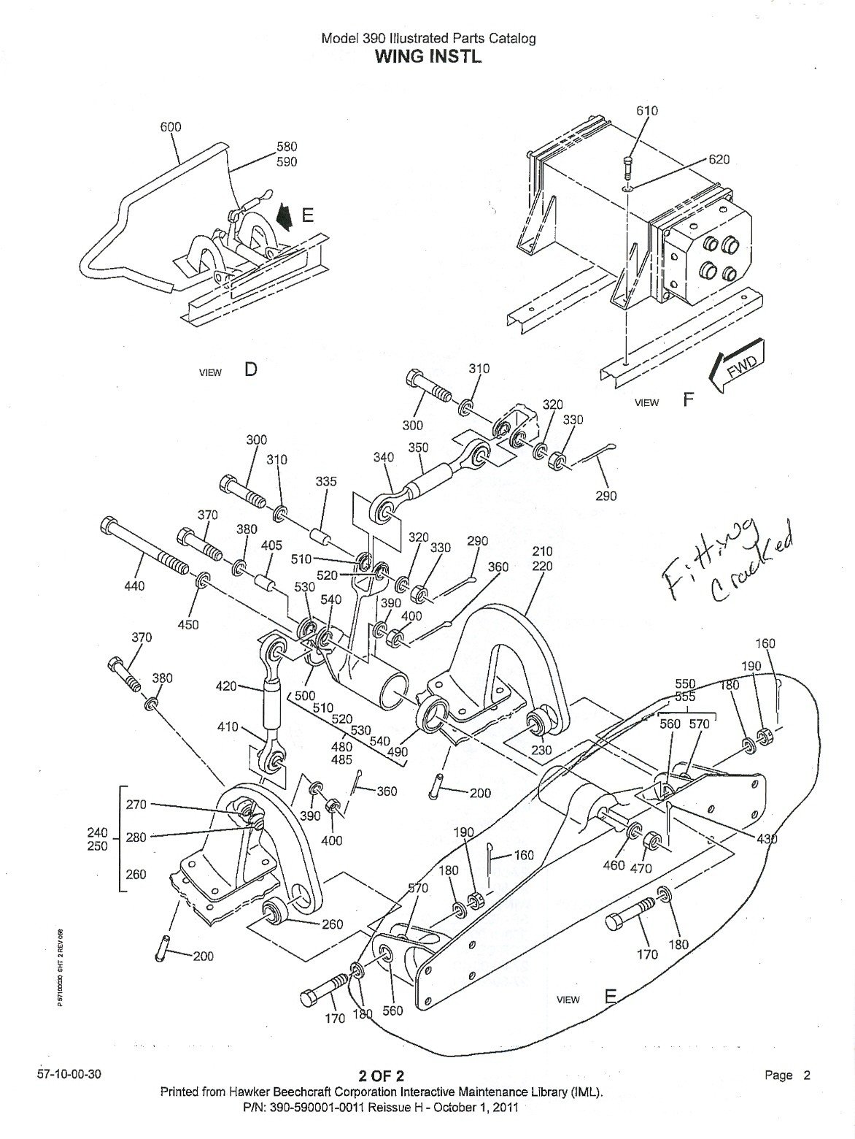



















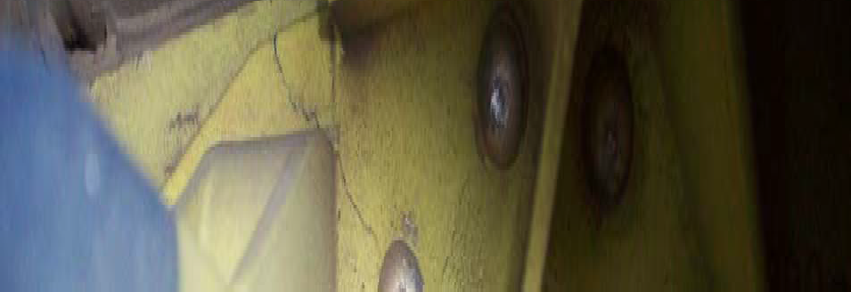







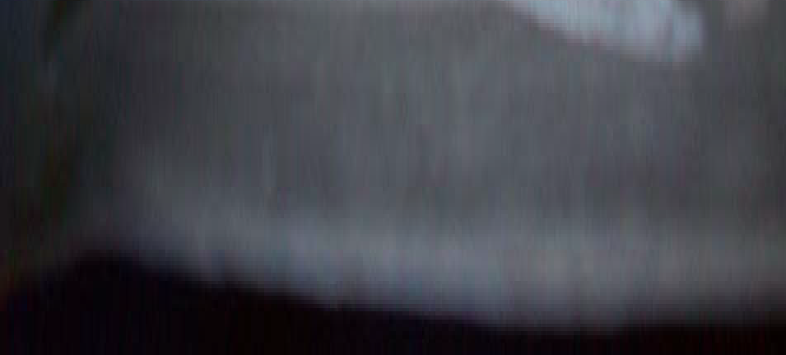

Part Total Time: 980 Hours